Reetique Stores – Financial Analysis Report

1. Project Overview
This project presents a comprehensive financial analysis of Reetique Stores using an interactive Power BI dashboard. The goal is to evaluate business performance across key dimensions such as sales, profit, discount strategies, and regional/segment-level insights.
The dashboard enables stakeholders to identify trends, uncover inefficiencies, and make data-driven decisions to improve overall profitability.

2. Business Problem Statement
Reetique Stores is experiencing strong growth in sales and overall profit; however, its profit margins are declining. This indicates inefficiencies in pricing, discount strategies, and segment-level performance.

3. Objectives
- Analyze year-over-year performance of sales, profit, and orders
- Evaluate the impact of discount strategies on profit margins
- Identify high-performing and low-performing countries
- Analyze segment-wise and product-wise profitability
- Provide actionable recommendations

4. Key Performance Indicators (KPIs)
- Total Sales: $92.3M (+249.46% YoY)
- Total Orders: 861.1K (+225.36% YoY)
- Total Profit: $13.0M (+235.58% YoY)
- Profit Margin: 14.1% (↓ from 14.7%)
- Total Discount: $7.1M (+229.04% YoY)

5. Dashboard Insights

5.1 Sales & Growth Analysis
Strong growth in sales and orders indicates high demand but raises sustainability concerns.

5.2 Profitability Analysis
Profit increased but margins declined, indicating cost or discount inefficiencies.

5.3 Discount Analysis
Majority discounts fall in the high band, impacting profitability.

5.4 Country-wise Performance
Germany and France perform well, while the US shows lower margins.

5.5 Segment-wise Performance
Government is highly profitable, while Enterprise is loss-making.

5.6 Product-wise Analysis
Few products dominate revenue, increasing dependency risk.

6. Key Issues Identified
- Declining profit margins
- Overuse of discounts
- Loss-making Enterprise segment
- Regional imbalance
- Product dependency risk

7. Recommendations

7.1 Optimize Discount Strategy
Shift to targeted and seasonal discounts.

7.2 Improve Segment Profitability
Fix or eliminate loss-making products in Enterprise.

7.3 Regional Optimization
Standardize pricing and cost structures.

7.4 Product Portfolio Optimization
Focus on high-margin products.

7.5 Sustainable Growth Strategy
Move from discount-driven to value-driven growth.

8. Dashboard

8.1 Overall Dashboard View
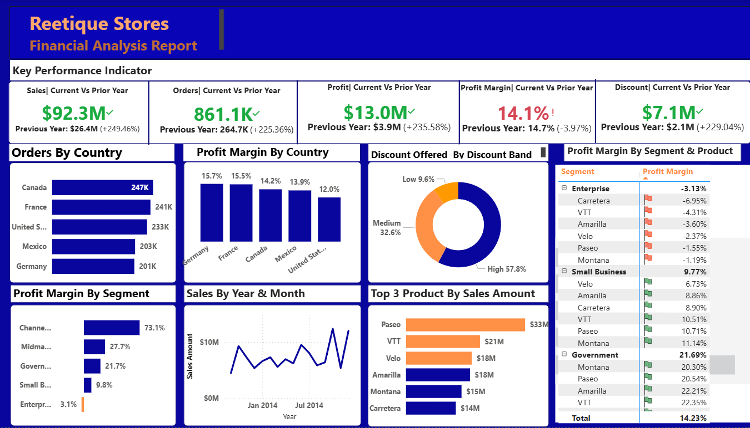
Comprehensive overview of Reetique Stores financial performance, including KPIs, sales trends, profitability, and discount distribution.

8.2 KPI Summary Section
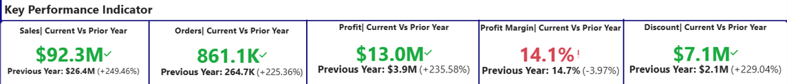
Key performance indicators showing year-over-year growth in sales, profit, orders, and discount levels, along with a decline in profit margin.

8.3 Sales Trend Analysis
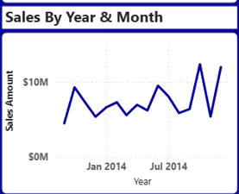
Yearly sales trend illustrating revenue fluctuations and overall growth pattern across the selected time period.

8.4 Country-wise Performance
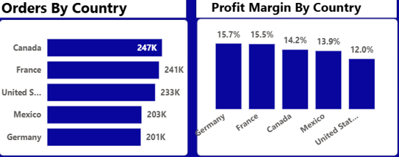
Comparison of orders and profit margins across countries, highlighting high-performing and underperforming regions.

8.5 Segment-wise Profitability
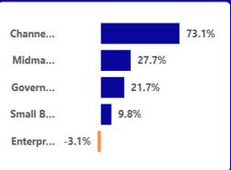
Profit margin distribution across business segments, identifying Government as the most profitable and Enterprise as loss-making.

8.6 Product Performance
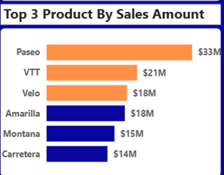
Top 6 -performing products based on total sales, showing revenue concentration among key products.

8.7 Discount Analysis
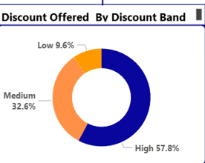
Breakdown of discounts by band (Low, Medium, High), indicating heavy reliance on high discount strategies.

8.8 Segment & Product Matrix
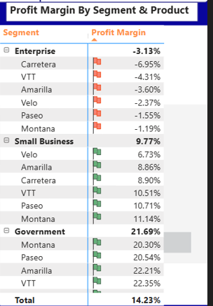
Detailed matrix showing profit margins by segment and product, highlighting areas of negative and positive performance.

9. Tools Used
- Excel (Data Cleaning)
- Power BI (Dashboard & Visualization)
- Data Modeling (DAX, Relationships)
- SQL (Exploratory Data Analysis)

10. Conclusion
The dashboard reveals that Reetique Stores is achieving strong revenue growth but facing declining profitability due to excessive discounting and underperforming segments.
Strategic improvements in pricing, discount control, and segment optimization can significantly enhance overall business performance.

✨ This report demonstrates the power of Power BI in transforming raw data into actionable business insights.

